**Implement Min, Max, Sum and Average operations using Parallel Reduction.**

#include <iostream>

//#include <vector>

#include <omp.h>

#include <climits>

using namespace std;

void min_reduction(int arr[], int n) {

int min_value = INT_MAX;

#pragma omp parallel for reduction (min: min_value)

for (int i = 0; i < n; i++) {

if (arr[i] < min_value) {

min_value = arr[i];

}

}

cout << "Minimum value: " << min_value << endl;

}

void max_reduction(int arr[], int n) {

int max_value = INT_MIN;

#pragma omp parallel for reduction (max: max_value)

for (int i = 0; i < n; i++) {

if (arr[i] > max_value) {

max_value = arr[i];

}

}

cout << "Maximum value: " << max_value << endl;

}

void sum_reduction(int arr[], int n) {

int sum = 0;

#pragma omp parallel for reduction (+: sum)

for (int i = 0; i < n; i++) {

sum += arr[i];

}

cout << "Sum: " << sum << endl;

}

void average_reduction(int arr[], int n) {

int sum = 0;

#pragma omp parallel for reduction (+: sum)

for (int i = 0; i < n; i++) {

sum += arr[i];

}

cout << "Average: " << (double)sum / (n-1) << endl;

}

int main () {

int *arr,n;

cout<<"\n enter total no of elements=>";

cin>>n;

arr=new int[n];

cout<<"\n enter elements=>";

for (int i=0; i<n;i++)

{

cin>>arr[i];

}

// int arr[] = {5, 2, 9, 1, 7, 6, 8, 3, 4};

// int n = size(arr);

min_reduction (arr, n);

max_reduction (arr, n);

sum_reduction (arr, n);

average_reduction (arr, n);

}

Output

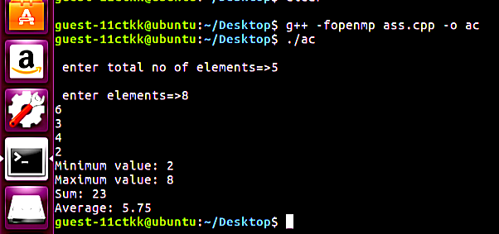

**Void Min_reduction()**

* void min_reduction(vector<int>& arr) declares a void function that takes a reference to an integer vector as its argument.
* int min_value = INT_MAX; initializes an integer variable min_value to the largest possible integer value using the INT_MAX constant from the <climits> header file. This is done to ensure that min_value is initially greater than any element in arr.
* #pragma omp parallel for reduction (min: min_value) is an OpenMP directive that specifies that the following loop should be executed in parallel using multiple threads. The reduction (min: min_value) clause indicates that each thread should maintain a private copy of min_value and update it with the minimum value it finds in its portion of the loop. Once the loop is complete, OpenMP will combine all the private copies of min_value into a single shared value that represents the minimum value in arr.
* for (int i = 0; i < arr.size(); i++) { is a loop that iterates over each element of arr.
* if (arr[i] < min_value) {min_value = arr[i]; } checks if the current element of arr is less than min_value. If so, it updates min_value to be the current element.
* cout << "Minimum value: " << min_value << endl; prints out the minimum value found in arr.

**void max_reduction ()**

* void max_reduction(vector<int>& arr) declares a void function that takes a reference to an integer vector as its argument.
* int max_value = INT_MIN; initializes an integer variable max_value to the smallest possible integer value using the INT_MIN constant from the <climits> header file. This is done to ensure that max_value is initially smaller than any element in arr.
* #pragma omp parallel for reduction (max: max_value) is an OpenMP directive that specifies that the following loop should be executed in parallel using multiple threads. The reduction (max: max_value) clause indicates that each thread should maintain a private copy of max_value and update it with the maximum value it finds in its portion of the loop. Once the loop is complete, OpenMP will combine all the private copies of max_value into a single shared value that represents the maximum value in arr.
* for (int i = 0; i < arr.size(); i++) { is a loop that iterates over each element of arr.
* if (arr[i] > max_value) {max_value = arr[i];} checks if the current element of arr is greater than max_value. If so, it updates max_value to be the current element.
* cout << "Maximum value: " << max_value << endl; prints out the maximum value found in arr.

**#include <climits>**

<climits> is a header file in C++ that contains constants related to integer types. This header file provides implementation-defined constants for minimum and maximum values of integral types, such as INT_MAX (maximum value of int) and INT_MIN (minimum value of int).

Using these constants instead of hardcoding the values of the minimum and maximum integer values is a good practice because it makes the code more readable and avoids the possibility of introducing errors in the code. The use of these constants also ensures that the code will work correctly across different platforms and compilers.

**INT_MIN:**

Minimum value for an object of type int

Value of INT_MIN is -32767 (-215+1) or less*

**INT_MAX:**

Maximum value for an object of type int

Value of INT_MAX is 2147483647 (-231 to 231-1)